Normalization Exercise

1) Your task in this exercise is to move the un-normalized table to 3NF. To do this, use the dependency diagram.
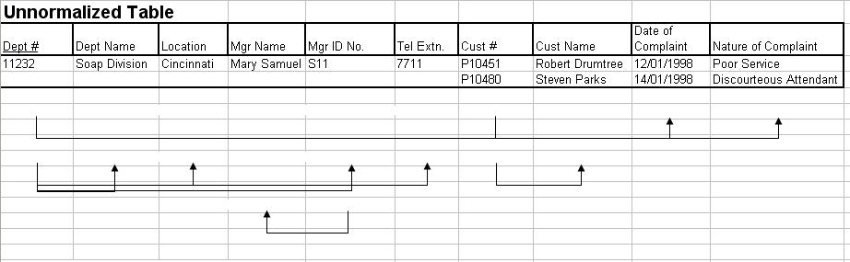

0NF

Department(Dept # PK,Dept Name,Location,Mgr ID No.,Mgr Name,Tel Extn.

,Cust #,Cust Name,Date of Complaint,Nature of Complaint )

1NF

Department(Dept # PK,Dept Name,Location,Mgr ID No.,Mgr Name,Tel Extn.)

Complaint ((Dept # FK,Cust #) PK,Cust Name,Date of Complaint,Nature of Complaint )

2NF

Department(Dept # PK,Dept Name,Location,Mgr ID No.,Mgr Name,Tel Extn.)

Complaint ((Dept # FK,Cust # FK ) PK,Date of Complaint,Nature of Complaint )

Cust (Cust # PK , Cust Name, )

3NF

Department(Dept # PK,Dept Name,Location,Mgr ID No. FK ,Tel Extn.)

Department_Mgr ( Mgr ID No. PK ,Mgr Name)

Complaint ((Dept # FK,Cust # FK ) PK,Date of Complaint,Nature of Complaint )

Cust (Cust # PK , Cust Name, )

MAYBE

Complaint ((Dept # FK,Cust # FK ) PK,Date of Complaint FK )

Complaint (Date of Complaint PK,Nature of Complaint )

2. Employee and Projects
The table below depicts the requirements for a business consultancy working on local and international projects.
Emp-No | Emp-Name | Dept | Dept Manager | Proj-id | Proj-Start-Date | Location | Weeks-on-Project
005 | Smith | Marketing | Jones | (A, B, C) | (12-93,  06-94,  09-94) | (Poole, Plymouth, Portsmouth) | (11, 15, 6)
007 | Bond | Accounts | Bloggs | (B, D) | (06-94,  06-94) | (Plymouth, Berlin) | (3, 9)
009 | King | Info Systems | Hurne | C | 09-94 | Portsmouth | 10
010 | Holt | Accounts | Bloggs | A  B  D | (12-93, 06-94,  06-94) | (Poole,  Belfast, Hamburg ) | (21,10, 12)
Emp.no is the primary key. Employees work on a number of projects concurrently. Weeks-on-project represents the number of weeks that an employee has spent on a particular. The employee number, emp-no, and the project identifier, project-id, are unique identifiers. The department manager, manager, is the name of the current manager, i.e., there can be only one manager per department. A project can take place in several locations (i.e Employees can work on a project from their location). You are required to show the first, second and third normal forms.
0NF

Employee_Projects(Emp-No PK , Emp-Name,Dept,Dept Manager,

Proj-id,Proj-Start-Date,Location,Weeks-on-Project)

1NF

Employee(Emp-No PK , Emp-Name,Dept,Dept Manager)

Projects(( Emp-No FK, Proj-id ) PK ,Proj-Start-Date,Weeks-on-Project)

Project_Loc ( ( Emp-No , Proj-id) FK , Location ) PK )

2NF

Employee(Emp-No PK , Emp-Name,Dept,Dept Manager)

Projects(( Emp-No FK, Proj-id FK) PK ,Weeks-on-Project)

Proj_Start_Date( Proj-id PK ,Proj-Start-Date )

Project_Loc ( ( Emp-No FK , Proj-id , Location ) PK )

3NF

Employee(Emp-No PK , Emp-Name,Dept FK)

Employee_Manag (Dept PK ,Dept Manager)

Projects(( Emp-No FK, Proj-id FK) PK ,Weeks-on-Project)

Proj_Start_Date( Proj-id PK ,Proj-Start-Date )

Project_Loc ( ( Emp-No FK , Proj-id , Location ) PK )

